

**Online Course Certification With Document**

**Artificial Intelligence And Machine Learning**

**Academic Year 2025 - 26**

**Department : Computer science engineering**

**Student Name : Ranganath N**

**Class : 3rd Year CS**

**Reg No: 197CS23041**

**Submited By : Ranganath N**

**Submited To : Ramya Mam**

Teacher Signature :

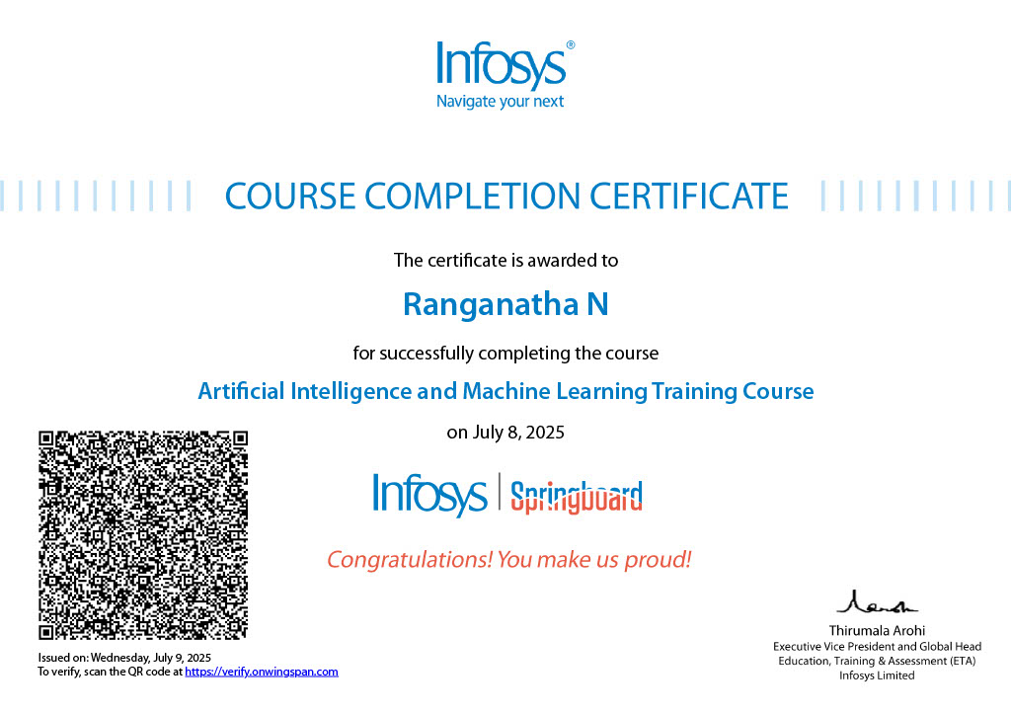

About this course:

Machine Learning (ML) is one of the key tenets in the field of Artificial Intelligence. Organizations such as Google, Facebook, Uber, Netflix, etc. have been leveraging machine learning to provide improved and engaging experiences to their consumers.

Although various machine learning techniques have been conceptualized and are in use for several decades now, the current demand for ML is fueled by the high availability of data and resources for computing this data. This technique is being deployed by industry for business benefits.

This course serves as an introduction to various ML concepts such as Regression, Classification, Clustering and Neural Networks. At the end of this course, you should be familiar with the key ideas powering these concepts and also develop programs (in Python), that use them

Concepts you must know before doing this course:

* Generic overview of Artificial Intelligence (AI).
* Basic knowledge of  Python programming language.
* Hands-on experience in Data Science related Python libraries such as numpy, pandas, and matplotlib.

Software Requirements For This Course:

* Anaconda distribution of Python 3.5 or above

Learning Outcomes:

* Identify the type of machine learning problem for a given use case.
* Apply Classification, Regression and Clustering algorithms to various problems using Python.
* Explore various validation techniques for machine learning models.
* Understand what is Artificial Neural Networks (ANN).

## ai & ml.jpg

## What Is Artificial Intelligence And Machine Learning

Artificial Intelligence:

Artificial Intelligence is the field of developing computers and robots that are capable of behaving in ways that both mimic and go beyond human capabilities. AI-enabled programs can analyze and contextualize data to provide information or automatically trigger actions without human interference.

Today, artificial intelligence is at the heart of many technologies we use, including smart devices and voice assistants for example such as Siri on Apple devices.

Machine Learning:

Machine learning is a pathway to artificial intelligence. This subcategory of AI uses algorithms to automatically learn insights and recognize patterns from data, applying that learning to make increasingly better decisions.

By studying and experimenting with machine learning, programmers test the limits of how much they can improve the perception, cognition, and action of a computer system.

Deep learning, an advanced method of machine learning, goes a step further. Deep learning models use large neural networks — networks that function like a human brain to logically analyze data — to learn complex patterns and make predictions independent of human input.

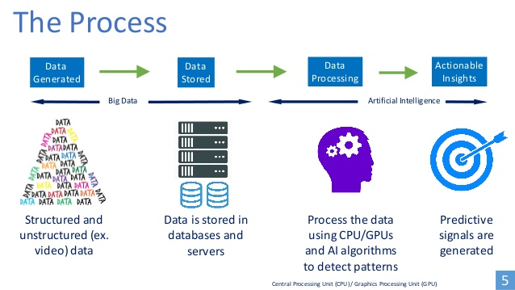How AI Process Works ?

Artificial Intelligence (AI) works by simulating human intelligence through the use of algorithms, data, and computational power. The goal is to enable machines or software to perform tasks that typically require human intelligence, such as learning, reasoning, problem-solving, perception, and language understanding.

Machine Learning Process ?

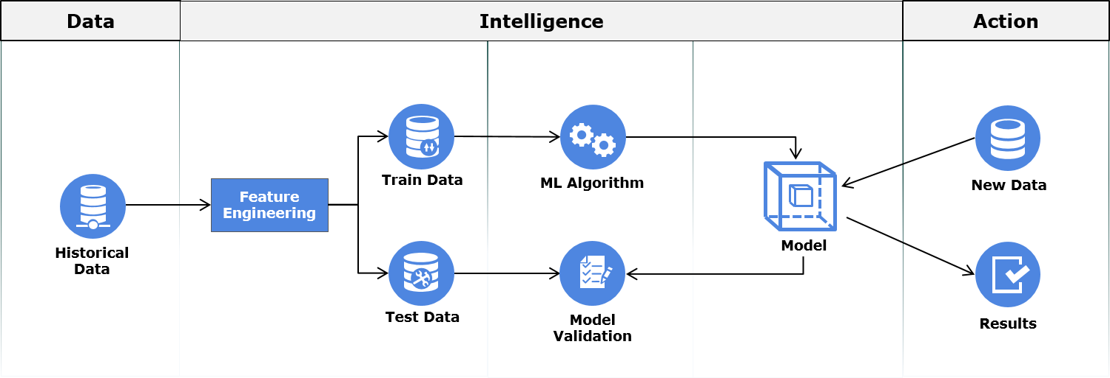In this process, first relevant data is gathered then is cleaned and transformed through a process called Feature Engineering. During the process of Feature Engineering, handling missing value, handling outliers, creating new features out of existing ones are some of the common tasks performed.

After feature engineering, the data is split into Train Data and Test Data. The Train Data is used for training the machine learning model. Once the model is built, it is validated against the Test Data for accuracy. This accuracy helps us in estimating the performance on previously unseen data. If the model performance on both Train and Test Data is satisfactory, the model may be deployed. Once deployed, the model makes predictions on new data these predictions insights are used to take business decisions.

Goals And Objectives Of AI And Ml

### 1. Problem-Solving and Decision-Making

### 2. Natural Language Processing (NLP)

### 3. Machine Learning and Deep Learning

### 4. Robotics and Automation

### 5. Enhancing in Healthcare and Medicine ,Etc.

Feature Scope For AI And Ml

Artificial Intelligence and Machine Learning have a bright future in India and have enormous potential to transform every sector of the economy for the benefit of society

AI and ML in Education Sector

AI and ML in Evolution of Chatbots

AI and ML in Automated Grading System

AI and ML in Healthcare Sector

AI and ML in Transport Sector

AI and ML in Cyber Security

AI and ML in Manufacturing Sector

**Course summary**

In This 12 –Hour 52 Minute Course, We Learned About Artificial Intelligence And Machine Learning. An AI And Ml Specialist Is An It Professional Who Develops Intelligent Systems And Algorithms.They Apply A Wide Range Of Coding Skills And Helps Other Programmers Solve Complex Problem. AI And Ml Specialists Also Test And Debug Models And Optimize Algorithms For Better Performance